CS231: Project 3

Sudoku

**Abstract**

In the project, a Sudoku solver has been coded. The current project reads from the test.txt file and prints the solution out to the terminal, the solved board. In the meantime, the GUI window shows how the solver progresses step by step. Then, I have explored how long the board will take to solve when it starts with different numbers of locked values.

The data structure that has been used to implement this solver is a stack. This data structure works on the principle of LIFO which stands for Last In First Out. The stack saves all the cells that the program has attempted to solve with their values and is helpful in easily manipulating the Cells and their values to go through them until a solution is found.

A solved Sudoku board

**Exploration**

Values for different numbers of starting values are tabulated below:

|  |  |  |  |  |
| --- | --- | --- | --- | --- |
|  | 10 | 20 | 30 | 40 |
| 1 | 5 | 3 | 1 | 2 |
| 2 | 9 | 2 | 0 | 0 |
| 3 | 0 | 0 | 2 | 1 |
| 4 | 1 | 1 | 1 | 0 |
| 5 | 3 | 0 | 0 | 0 |
| 6 | 1 | 2 | 1 | 0 |
| 7 | 1 | 4 | 2 | 0 |
| 8 | 0 | 0 | 0 | 0 |
| 9 | 1 | 0 | 0 | 0 |
| 10 | 2 | 1 | 0 | 1 |
| Average | 2.3 | 1.3 | 0.7 | 0.4 |

Plotting the data, we get:

As such, it is evident that as the number of starting values goes up, the time taken to solve the problem goes down.

**Extension 1**

For my first extension, I have chosen to make the Blackjack game interactive. To do this, I have created a new method called *playerTurnInteractive*. This method allows for a user to use *true* as input to get hit with another card or *false* as input to stand. To get the input, I made the use of the *Scanner* class. A class called *Interactive* was then created to create an object of the *Blackjack* class and use it to play a game.

The method called *dealerTurn* was also modified to make the dealer keep hitting until the value of the dealer’s hand is less than 21. In the end, if the player has not gone bust, the dealer’s hand is checked for its value to identify the result.

The house wins when:

1. The player busts
2. The player does not bust and the dealer has 21
3. The player does not bust but the dealer’s hand is higher in value.

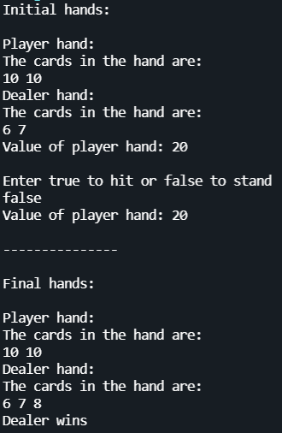

**Sample games**

**Extension 2**

For this extension, I increased the number of decks to six. This was done by modifying the *build()* function in the *Deck* class to include 24 each of cards with values 2-9 and 11, and 96 cards with the value 10. This makes it six decks in total

In a table below, I have plotted the results (win %) for 5 games and compared it with the results for using just one deck. An average of the five games has been taken to average out and statistical anomalies.

|  |  |  |  |  |  |  |
| --- | --- | --- | --- | --- | --- | --- |
| Serial Number | 1 deck | | | 6 decks | | |
| Player | House | Push | Player | House | Push |
| 1 | 41.7 | 49.7 | 8.6 | 41.2 | 49.6 | 9.2 |
| 2 | 42.2 | 47.3 | 10.5 | 41.8 | 48.0 | 10.2 |
| 3 | 38.9 | 52.8 | 8.3 | 41.4 | 49.0 | 9.6 |
| 4 | 40.3 | 51.9 | 7.8 | 42.7 | 49.1 | 8.2 |
| 5 | 43.3 | 48.4 | 8.3 | 44.4 | 45.8 | 9.8 |
| Average | 41.28 | 50.02 | 8.7 | 42.3 | 48.3 | 9.4 |

**Observations**

The findings from the table above are that even though there has been the difference of a few decimal places between the values of the house winning and the game ending in a push, the player wins approximately the same number of times. It can be concluded from the above data that changing the number of decks from 1 to 6 does not have a substantial effect on the chances of winning/losing/drawing this version of Blackjack.

**References/Acknowledgements**

I consulted both, Prof. Harper and Prof. Al Madi to discuss why my solve method might not be working. I also worked with Quan Phan to go over my code and help me find the bug that was causing my display to be rotated by 90 degrees. The *LandscapeDisplay* class was retrieved from <https://cs.colby.edu/aharper/courses/cs231/f21/labs/lab03/LandscapeDisplay.java> .